Tailor Management for Android



Session: 2015-2017

Submitted by
Tajmeer Khan
Reg’No: 153- NUN -0847
MCS (Morning)

Faculty of Engineering and Information Technology
Northern University, Nowshera

Tailor Management for Android

This project proposal is submitted to the Faculty of Engineering and Information Technology, Northern University, Nowshera as partial fulfillment of the requirement for the Master’s degree in computer Science as on
Date________________________

Author
[Author Name & Signature]

Supervisor
[Supervisor Name & Signature]

HOD ____________________________________
[HOD Name & Signature]

Table of Contents

Introduction

Objectives

Development Tools

Software Process Model

Network Hierarchy / Hierarchy Input Process Output (Diagram)

Preliminary Design

‘

Tailor Management for Android

Introduction
Tailor Management is an android application that will keep the record of the customers. It has the capability to search the customer’s record and facilitate users to set/schedule the information message to the customer. This application contains different types of cloths designs; user can select any of them. User’s cloths information will be saved in database for further use. When cloths dress up, an SMS will be send to the user (SMS will be send according to dead line time and date).

Objectives

- Taking information from customers (Inserting, Updating, Deleting)
  - General Information
  - Cloth measurement
- Schedule the message to customers for dressing up timing date
- Contains different categories of cloths
  - Male (Child, Adults, Men, Aged, Casual, Functions etc)
  - Female (Child, Adults, Men, Aged, Casual, Functions etc)
- Inserting new dress designs
- Deleting dress designs

Development Tools
- Platform Eclipse / Android Studio
- Language Java , XML
- Database SQLite
- Designing Tools Adobe Photoshop, Power Point

Software Process Model

The following prototyping model will be used in this project.

Prototyping Model

The prototyping model should be used when the system needs to have a lot of communication with end user. In this application there are many meetings among developers, user and supervisor. There may be chance of many changes in development place in this application. To keep their functionalities in mind, we have found that prototyping ensure that the end user constantly work with the system and provide a feedback which is incorporated in the prototype to result in a useable system. They are excellent for designing good human computer interface system.

Network Hierarchy

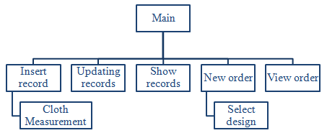

Figure 1: Network Model

Preliminary Design

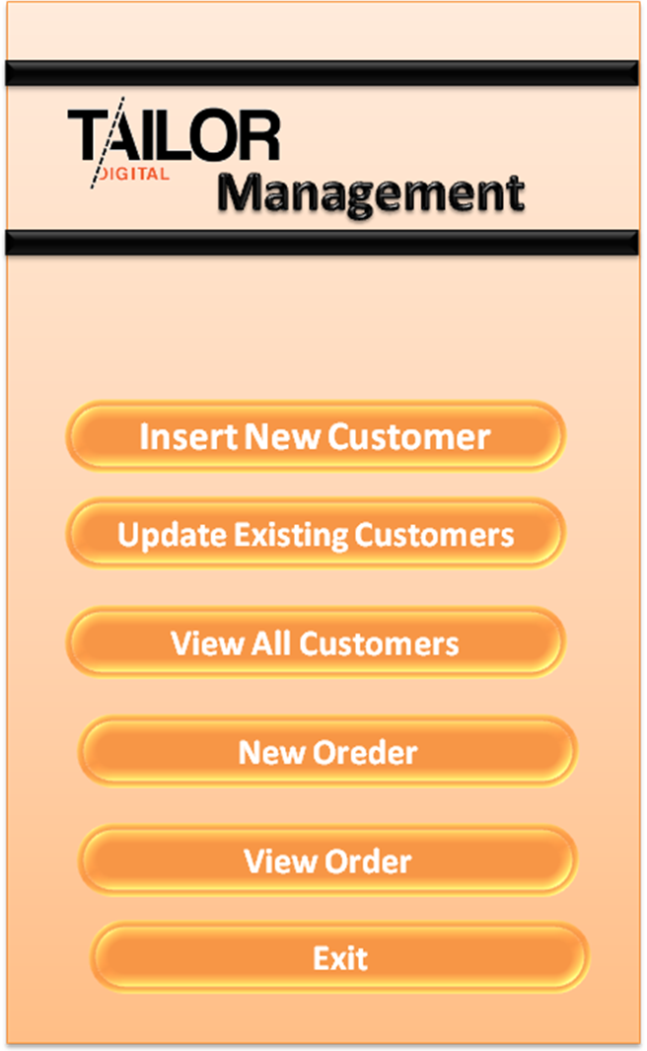
Figure 2: Main Layout of Tailor Management System

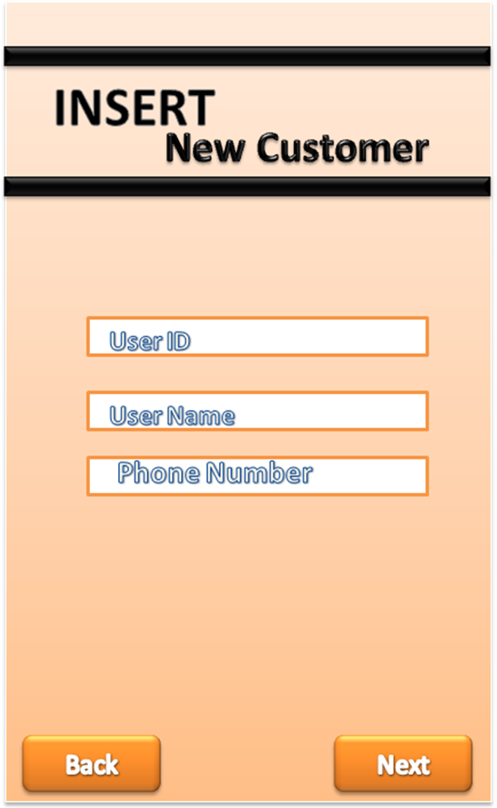
Figure 3: General layout of Tailor Management System

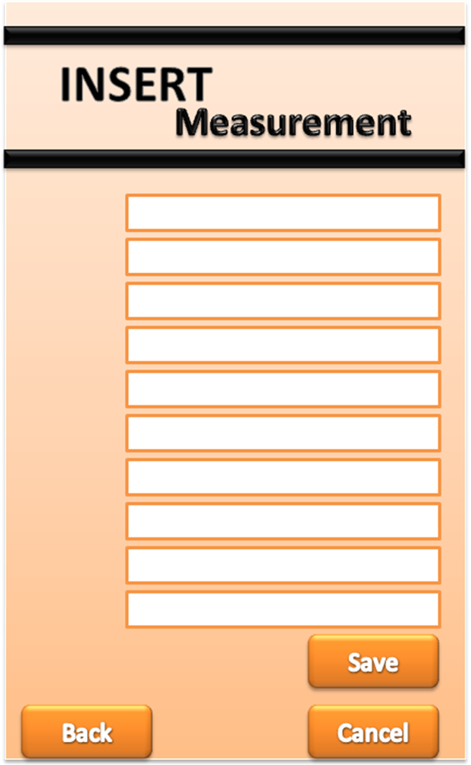
Figure 4: Measurement layout of Tailor Management System

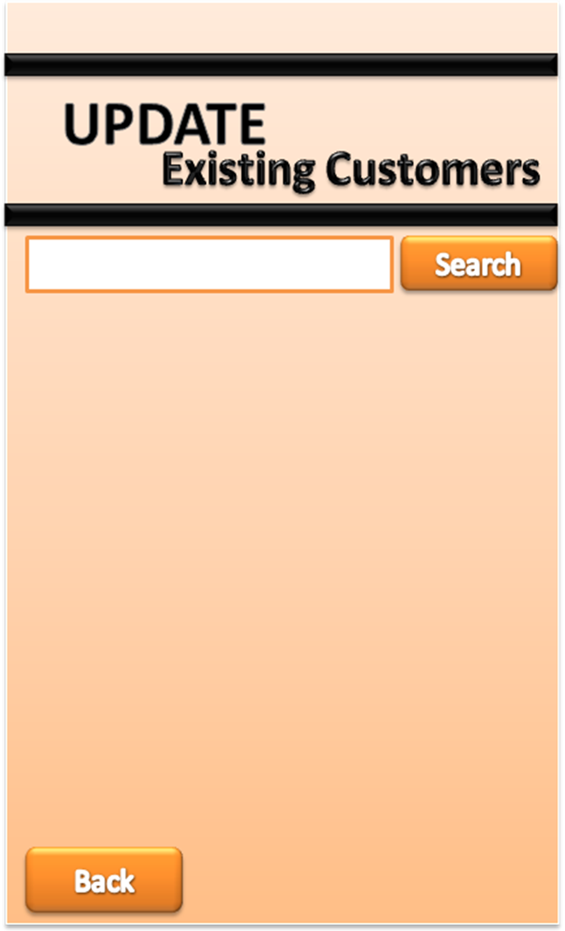
Figure 5: Update existing customer’s layout of Tailor Management System

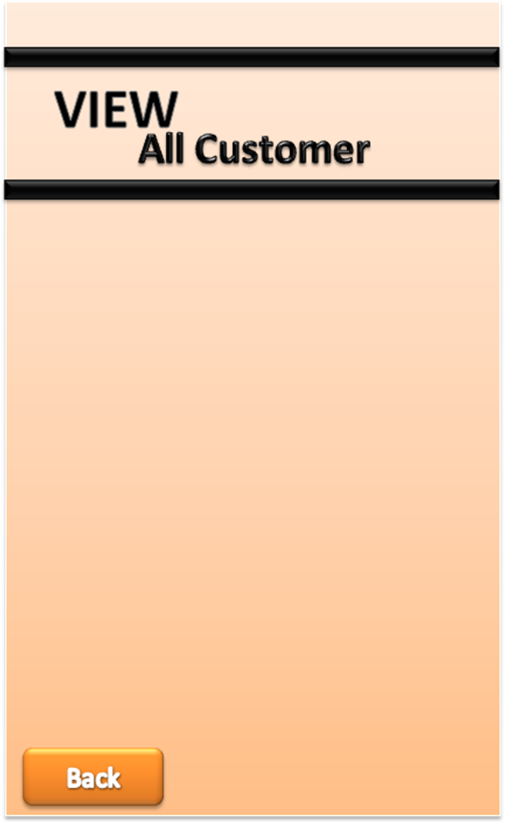
Figure 6: View all customer layout of Tailor Management System

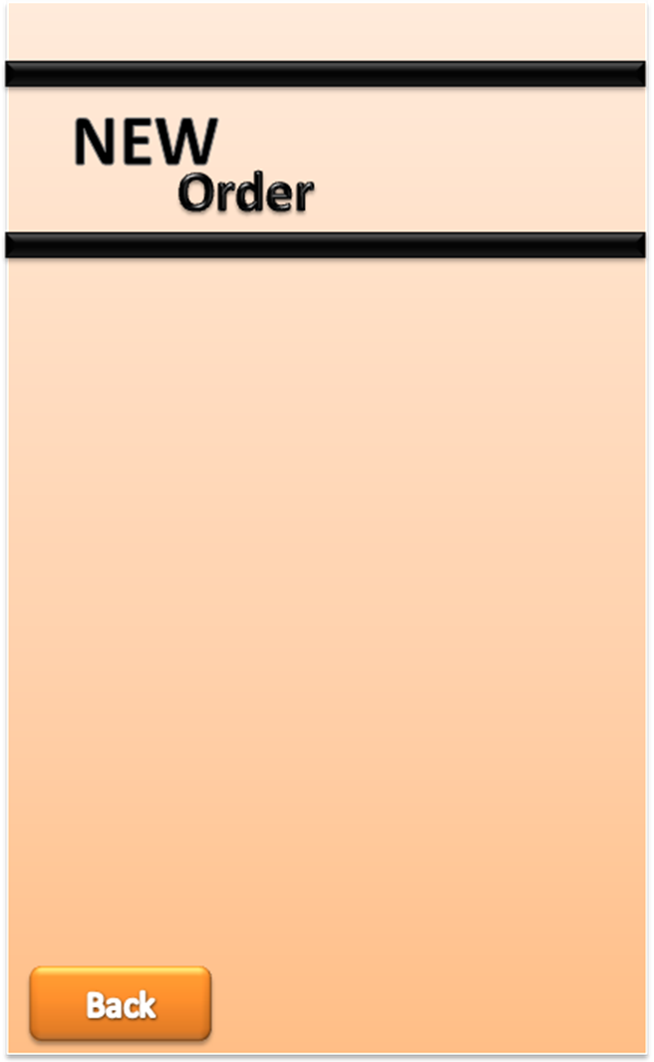
Figure 7: New order layout of Tailor Management System

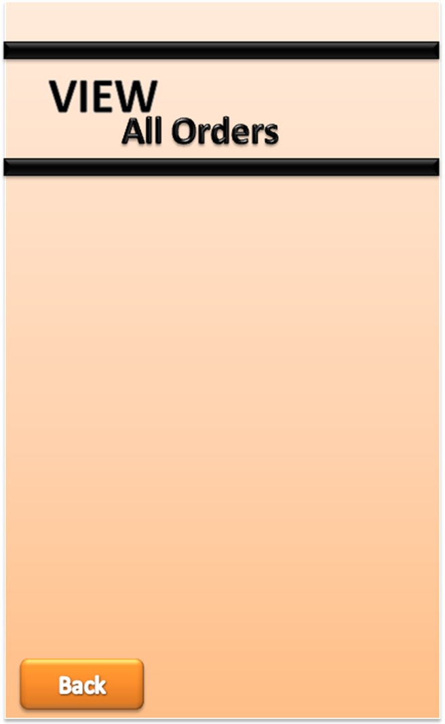
Figure 8: General layout of Tailor Management System

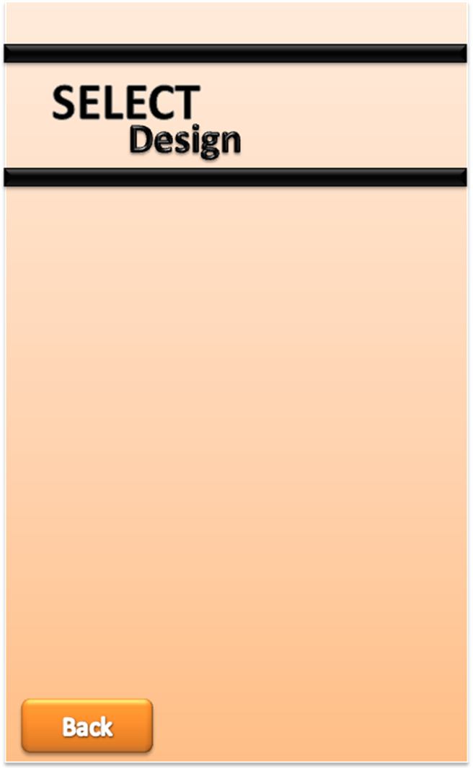
Figure 3: General layout of Tailor Management System

